2026 Warsaw Home & Outdoor Show
March 6 & 7
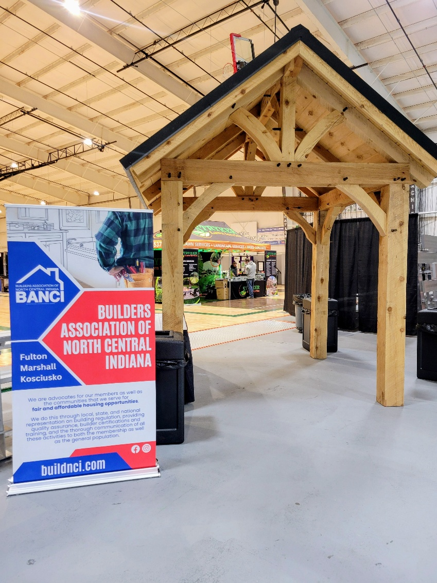
You are invited to join us next year to have a cash & carry table in our Home & Outdoor Show.
$35 for an 8’ table space
Friday March 6, 2:00-7:00
Saturday March 7, 9:00-6:00
Located in the T-Rac @ Warsaw High School
Craft Vendor Application
March 6 & 7, 2026
Warsaw High School @ the T-RAC
1 Tiger Lane, Warsaw
We are adding something new to our Home & Outdoor Show this year. We are hoping to add some cash & carry vendors to our show. We have 110 Vendor booths and are adding 8’ table space in the rows between the vendor booths. All registrations must be submitted with full payment by January 31, 2026. No refunds will be given due to expenses. Please complete the bottom portion of this form and return it to the address below by January 31, 2026. Tables will be sold on a first come first served basis as payment is received. Registration form will be accepted via email but will not be processed until payment is received. You will receive a confirmation email as soon as your application is processed.
Cash, Money Order, or checks payable to Banci may be mailed to:
523 S Buffalo St, Warsaw, IN 46580 * 574-267-6125 * Jackie@buildnci.com
Name:_______________________________________________________________________________________________
Address:_____________________________________________________________________________________________
Email:_______________________________________________________________________________________________
Cell #________________________________________________________________________________________________
Description Product:__________________________________________________________________________________
# of 8ft spaces ______ x $35 = $_________(A $35 fee will be charged for all NSF checks)
Warsaw Community Schools : Hold Harmless Agreement
Each member of the group must sign this agreement
As a prerequisite for the permission to use any WCS property, the renter and each participant agrees to indemnify and hold harmless the Warsaw Community Schools’ Board of Education; and any employee, agent or other representative on its behalf against any liability, type of damage, or loss or expense rising out of any claim, demand, action or cause of action which in any manner pertains to, concerns or involves any use of such school property which may, at any time, be made, commenced, or brought against such school district, its Board of Education or any employee, agent or other representative thereof. It is further understood and agreed that Warsaw Community Schools does not warrant the facility and equipment.
My signature below indicates that I have read, understand, and agree to the information presented above for Warsaw Community Schools, Warsaw Haigh School, Builders Association of North Central Indiana (Banci).
Signature:________________________________________Printed Name:______________________________________
Date:_____________________________________________

